**Perfecto Quantum Framework setup**

1. Install Java 1.8 version

Download URL: download the java 1.7 from [here](http://www.oracle.com/technetwork/java/javase/downloads/index-jsp-138363.html).

Download & Install both JDK and JRE from the above URL and set the JAVA_HOME as shown below:

1. Go to Control Panel\All Control Panel Items\User Accounts using Explorer (not Internet Explorer!)

**OR**

* + click on the Start button

[start](https://i.stack.imgur.com/MtRH1.png)

* + click on your picture

[](https://i.stack.imgur.com/CXkLU.png)

* Change my environment variables

[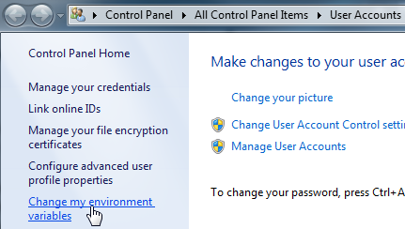](https://i.stack.imgur.com/r6sHR.png)

* New...

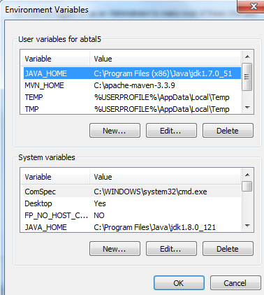

* (if you don't have enough permissions to add it in the System variables section, add it to the User variables section)
* Add JAVA_HOME as Variable name and the JDK location as Variable value as per your settings > OK

[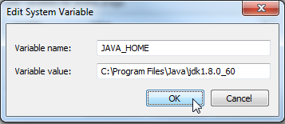](https://i.stack.imgur.com/H0onV.png)

1. Add your Java path to the path Environment variable as below

Add the value **%JAVA_HOME%\bin** to the path environment variable as shown below

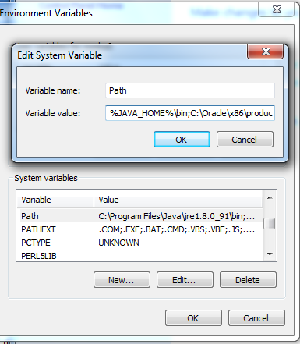

*Verify java installation***:**

Open a new console (cmd)

Type java -version

Expected output:

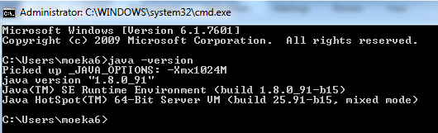

1. Install Maven 3.5.0 (<https://maven.apache.org/download.cgi>)
2. Install Eclipse Mars or above version (<http://www.eclipse.org/downloads/packages/eclipse-ide-java-developers/marsr>).

Download and unzip the Eclipse zip file.

1. After extracting the eclipse folder you can find the **eclipse.ini** file as shown below

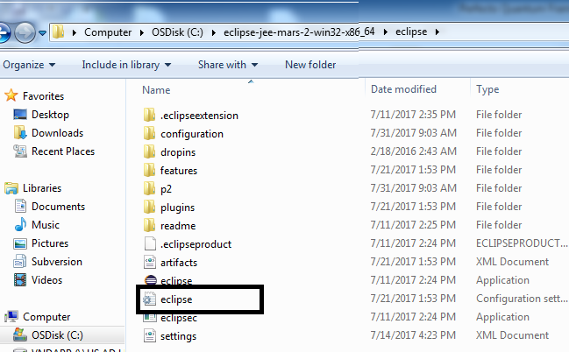

1. In Eclipse folder set your Java Path in **eclipse.ini**  file as shown below to avoid the multiple java versions problem

Place the below 2 lines before -vmrgs line in **eclipse.ini** file

-vm

C:\Program Files\Java\jdk1.8.0_60\bin\javaw.exe.

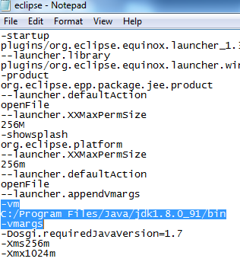

1. Install Maven plugin from <http://marketplace.eclipse.org/content/m2e-connector-maven-dependency-plugin>

Drag and Drop the below Install button to eclipse.

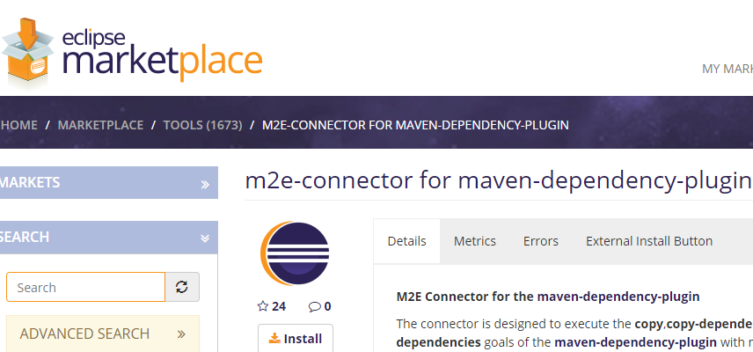

1. Install TestNG plugin from Eclipse market place as shown below

Open Eclipse and Select Help->Eclipse Marketplace …

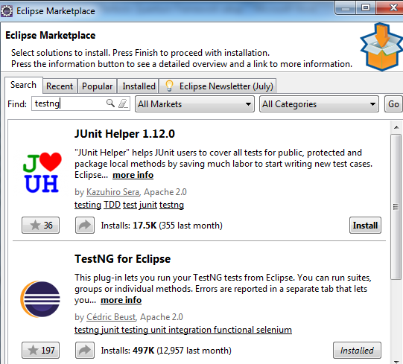

1. Try to install QAF Cucumber BDD plugin from <https://marketplace.eclipse.org/content/qaf-bdd-editors>
2. If QAF Cucumber BDD plugin Installed properly you will see the below 2 options in the Eclipse Help -> Installation details menu

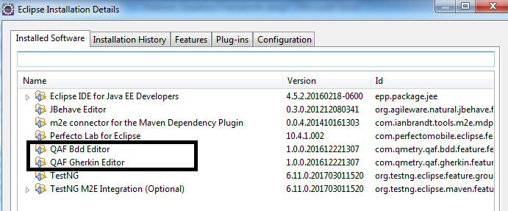

1. If you get any one exception like below

Cannot complete the install because one or more required items could not be found.

Software being installed: Cucumber Editor 0.7.6.201505100000 (org.agileware.natural.cucumber.feature.feature.group 0.7.6.201505100000)

Missing requirement: Cucumber Editor 0.7.6.201505100000 (org.agileware.natural.cucumber.feature.feature.group 0.7.6.201505100000) requires 'org.eclipse.xtext 2.1.0' but it could not be found

Unable to read repository at https://qmetry.github.io/qaf/editor/bdd/eclipse/content.xml.

sun.security.validator.ValidatorException: PKIX path building failed: sun.security.provider.certpath.SunCertPathBuilderException: unable to find valid certification path to requested target

Setup the below security certification by follow the directions in the attached document.



1. After installing the above certificate, now try again QAF Cucumber BDD plugin installation.
2. Get the perfecto credentials from LFG QC Support (if you don’t have it already).
3. Log into the Perfecto Lab and get the current version as shown below(Help ->About)

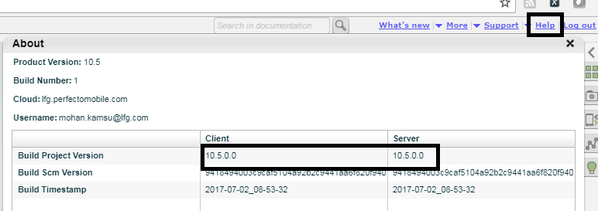

1. Install the Perfecto CQ Lab plugin from <https://www.perfectomobile.com/ni/resources/downloads/add-ins-plugins-and-extensions>
   1. Down load the plugin (down load the same version plug in matching with 15th step)
   2. Go to the eclipse and select Help->Install New Software option
   3. See the Install Dialog as show below and Click on Add Button

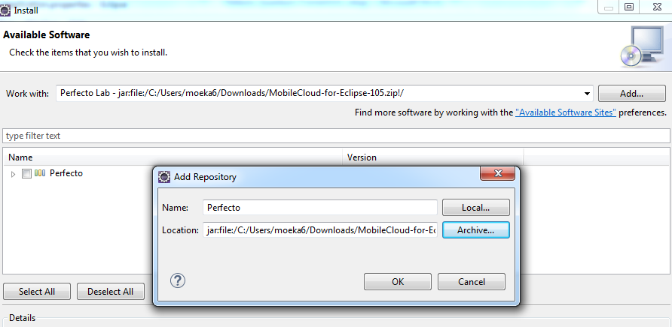

* 1. Enter Name as ‘Perfecto’ and Location as Plugin Download location as shown above and click OK
  2. Select Perfecto From Install window as shown below and click Next button

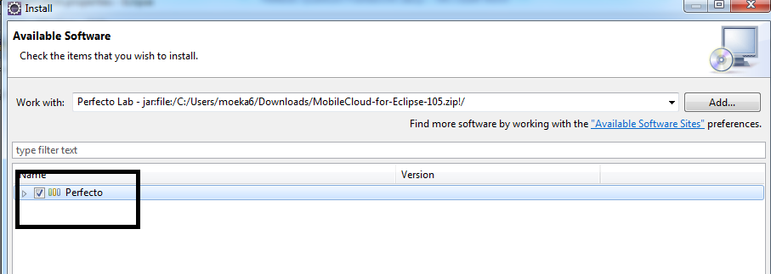

* 1. Follow the instructions and complete the installation

1. Go to Eclipse🡪Window🡪Preferences🡪Select Perfecto Lab and enter the Perfecto cloud credentials (cloud = <https://lfg.perfectomobile.com> , username and password)

**Importing and Executing Sample Script**

1. For getting the Quantum sample test, navigate to the below link: <https://github.com/Project-Quantum/Quantum-Starter-Kit> -->click on Clone or Download🡪Download ZIP.

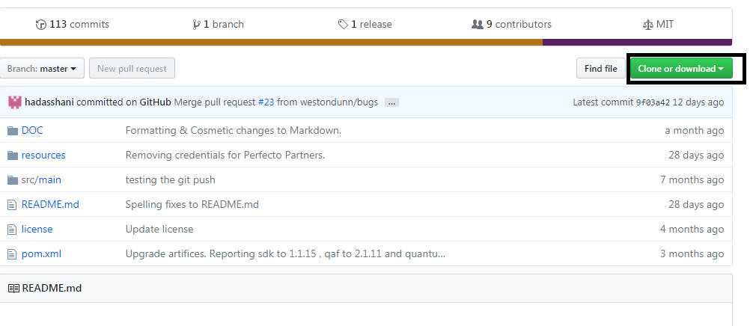

1. Unzip the download folder and import the project into Eclipse.

Open Eclipse

Navigate to File->Import

Select Maven->Existing Maven Projects as shown below

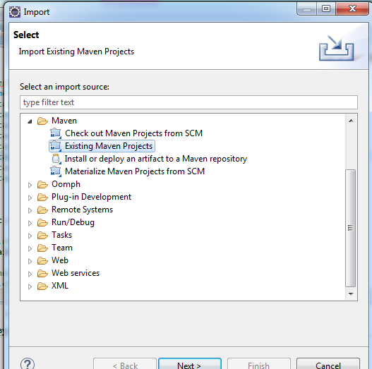

Click Next and Select downloaded sample script path and select the pom.xml file and click Finish button.

1. Select the **quantum-starter** sample project from Eclipse project explorer and Select **Resources** Folder and double click **“application.properties”** file as shown below

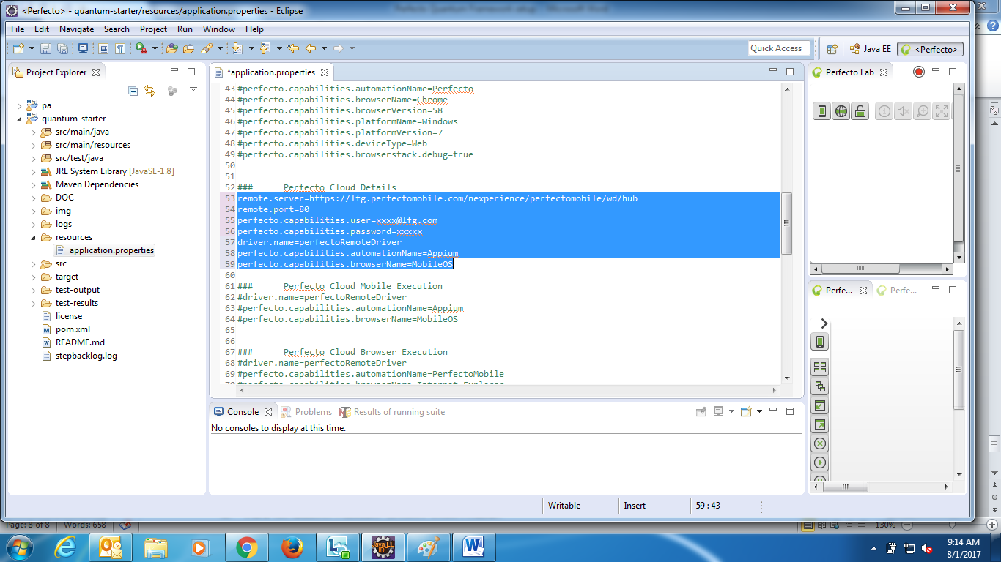

1. Set the Perfecto cloud details as shown below:

remote.server=https://lfg.perfectomobile.com/nexperience/perfectomobile/wd/hub

remote.port=80

perfecto.capabilities.user=lfgMailID@lfg.com

perfecto.capabilities.password=xxxxx

driver.name=perfectoRemoteDriver

perfecto.capabilities.automationName=Appium

perfecto.capabilities.browserName=MobileOS

1. Select the testng_web.xml from Eclipse Project as shown below

Quantum-Starter\src\main\resources\config\testng_web.xml

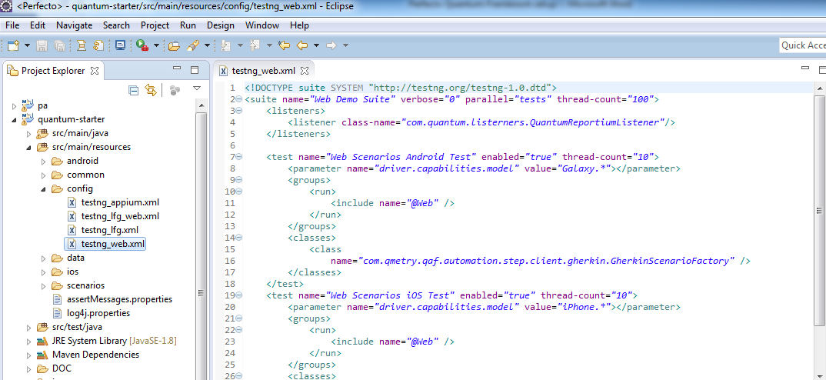

Select testng_web.xml file and right click and select Run As -> TestNG Suite as shown below

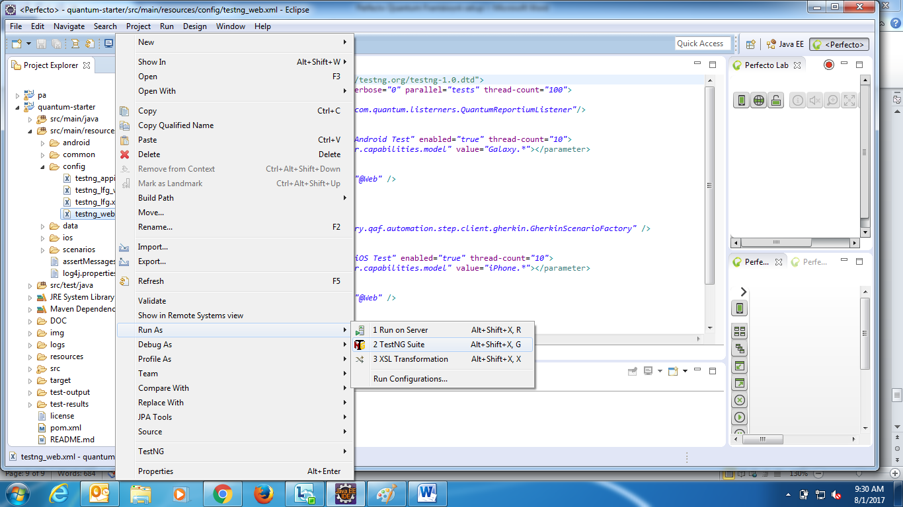

**Trouble shooting**

After importing sample Project into Eclipse if you see any errors in the project or exception like below

Could not calculate build plan: Plugin org.apache.maven.plugins:maven-resources-plugin:2.6 or one of its dependencies could not be resolved: Failed to read artifact descriptor for org.apache.maven.plugins:maven-resources-plugin:jar:2.6

Plugin org.apache.maven.plugins:maven-resources-plugin:2.6 or one of its dependencies could not be resolved: Failed to read artifact descriptor for org.apache.maven.plugins:maven-resources-plugin:jar:2.6

Follow the below steps as mentioned.

1. Place maven-compiler jar into the directory
   1. C:\Users\<username>\.m2\repository\org\apache\maven\plugins\maven-compiler-plugin\3.5.1
   2. Jar is retrievable from: <http://central.maven.org/maven2/org/apache/maven/plugins/maven-compiler-plugin/3.5.1/maven-compiler-plugin-3.5.1.jar>
2. Select Sample project from Eclipse and update the Project as shown below

Select quantum-starter project and right click and Select Maven and select Update Project

Option

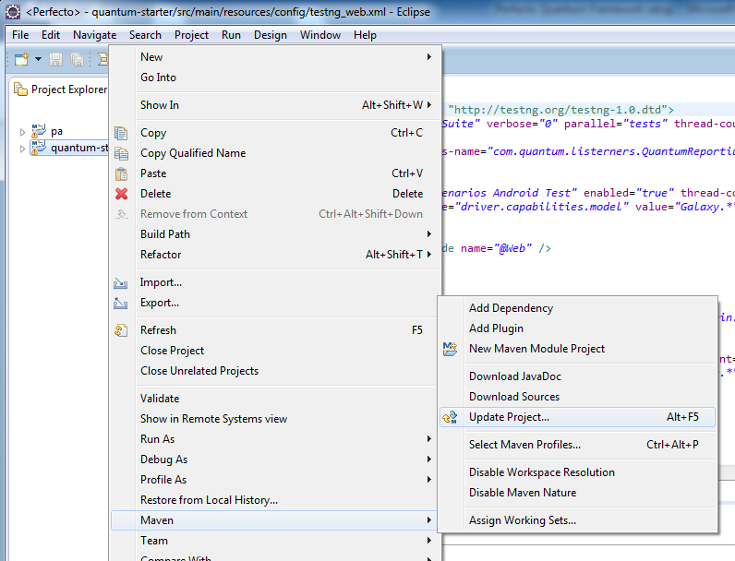

1. Place the attached settings.xml file in the path **C:\Users\<username>\.m2**

After changing the username in the settings file



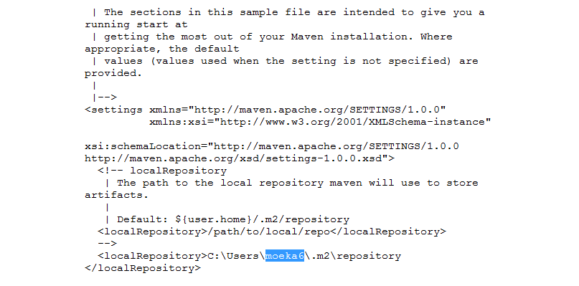

1. Now try to execute the Script Now.